**Screenshots of Output and how the project actually works**

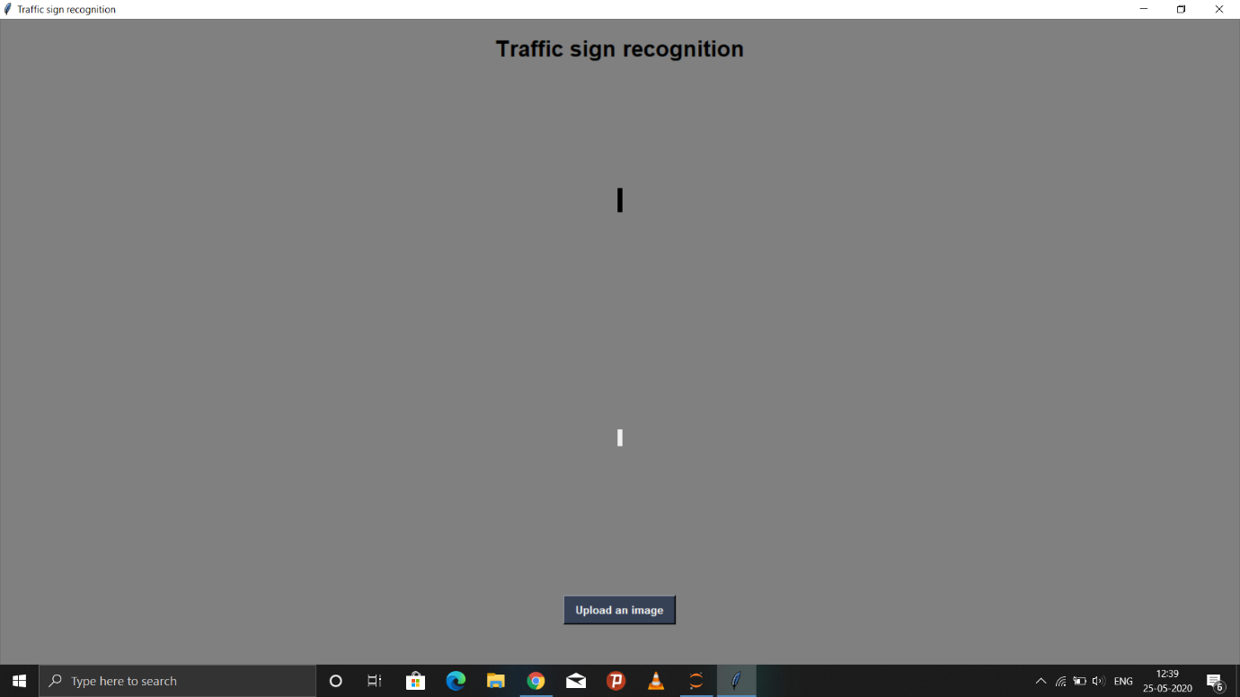

**Click on upload**

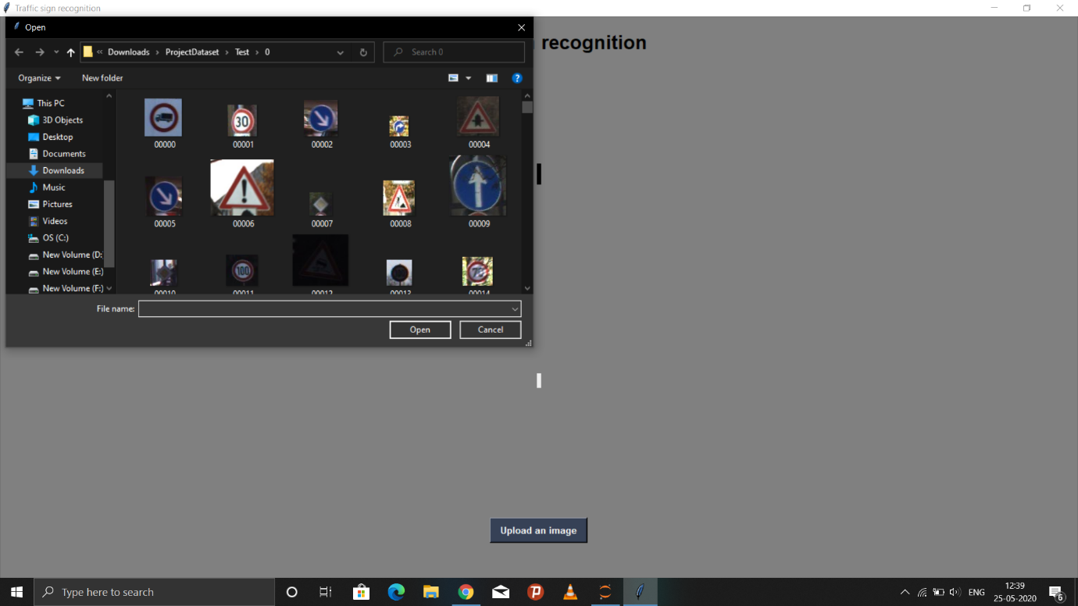

**Select Image**



**Selected Image**

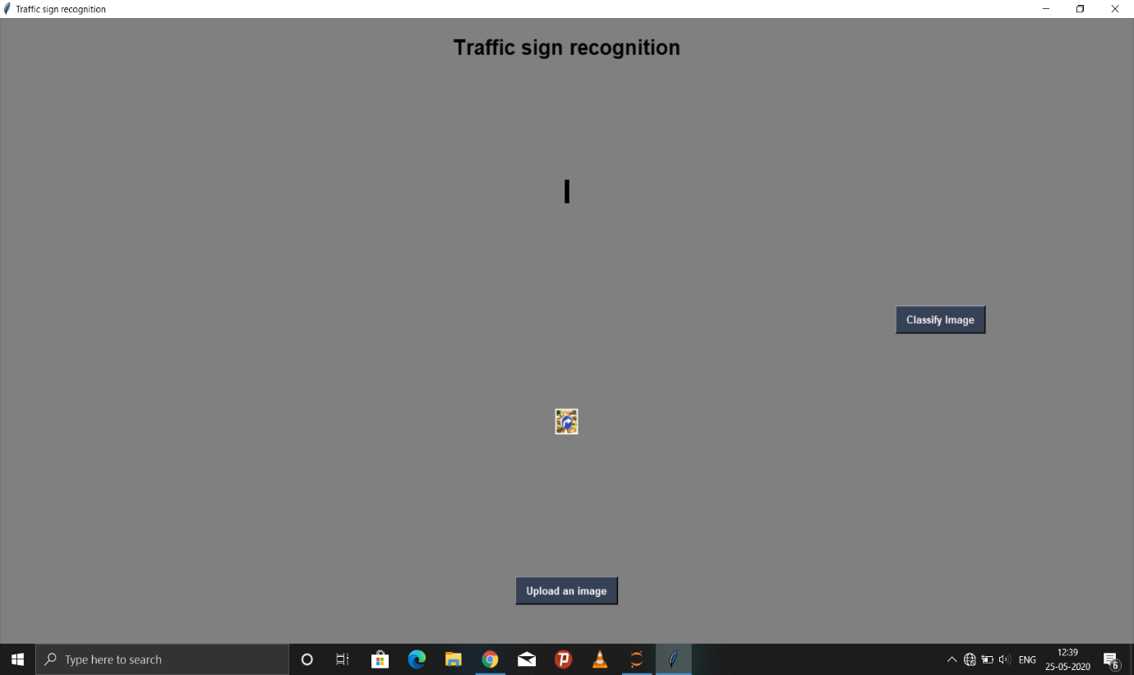

**Click on CLassify**

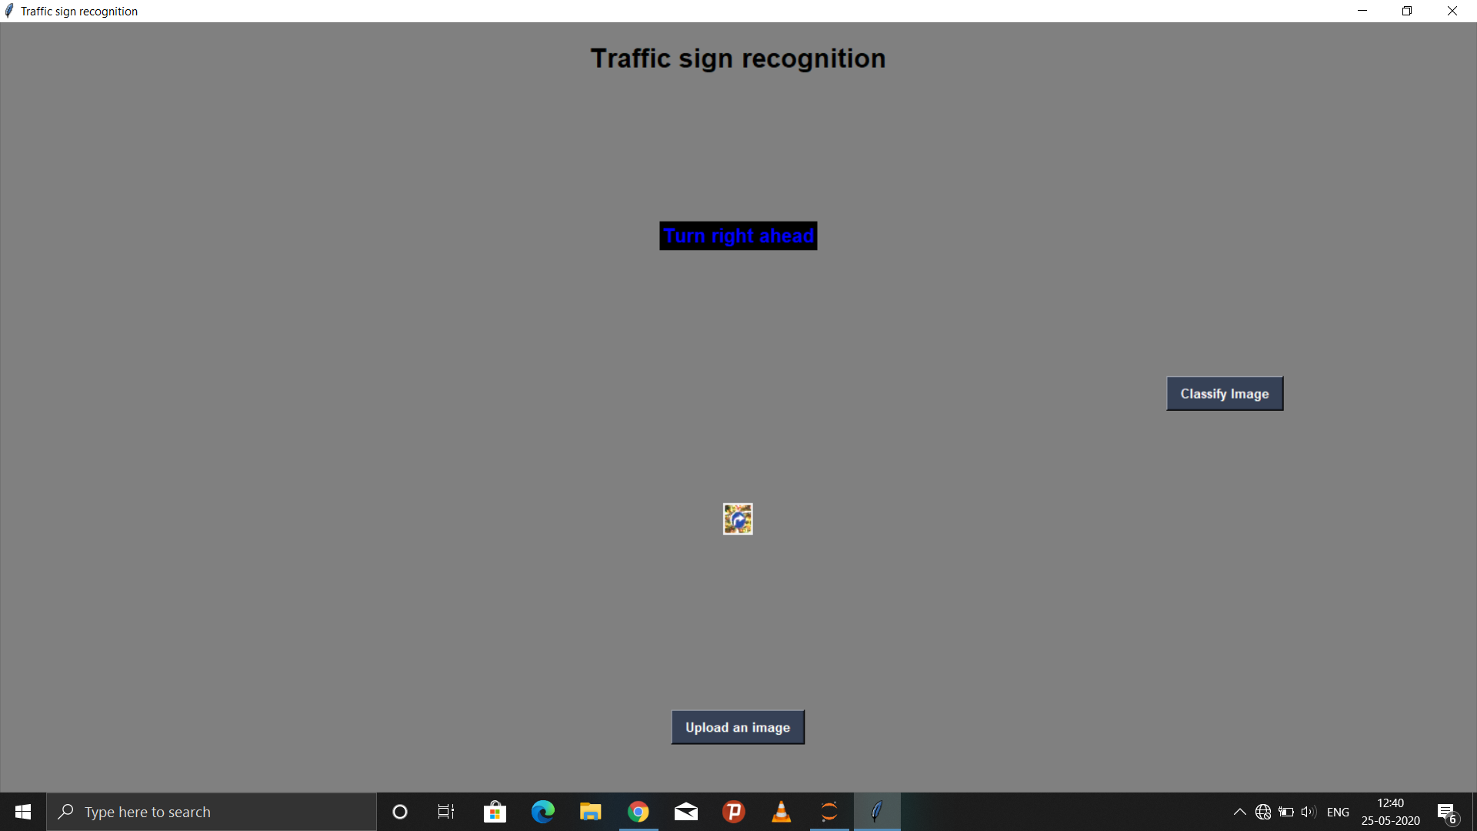

OUTPUT

**After Terminating the tkinter page it will be like:**

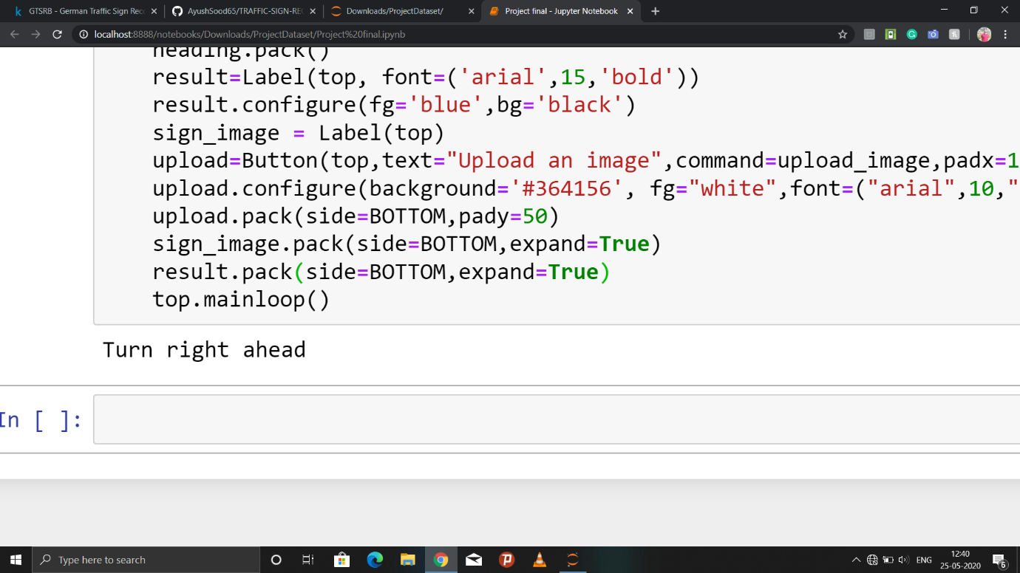

**It shows Output Here**